

Jonesboro Math & Science

First Grade Supply List

2015-2016

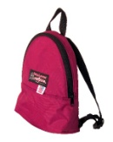

1 child-size backpack NO WHEELS

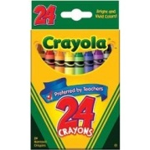

3 24 count Crayola crayons

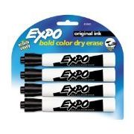

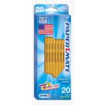

10 black EXPO dry erase markers

3 20 count boxes of Papermate pencils

[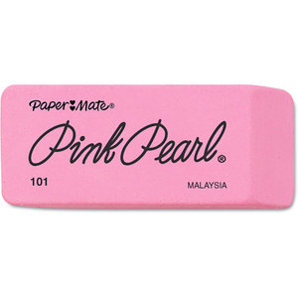](http://i.walmartimages.com/i/p/00/07/05/30/70/0007053070521_500X500.jpg)

4 Papermate Pink Pearl eraser

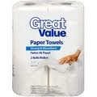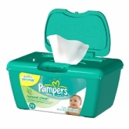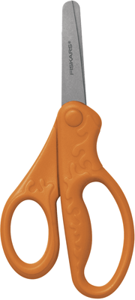[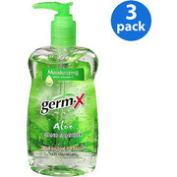](http://www.walmart.com/ip/Germ-X-W-Vitamin-E-Aloe-Hand-Sanitizer-10-fl-oz-3pk/12560503)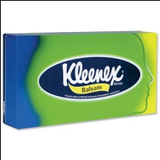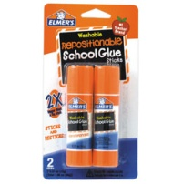

2 rolls of paper towels and 1 box of baby wipes

4 boxes of Kleenex

2 bottles of hand sanitizer with pump

1 pair of small child-size scissors

10 Elmer glue sticks